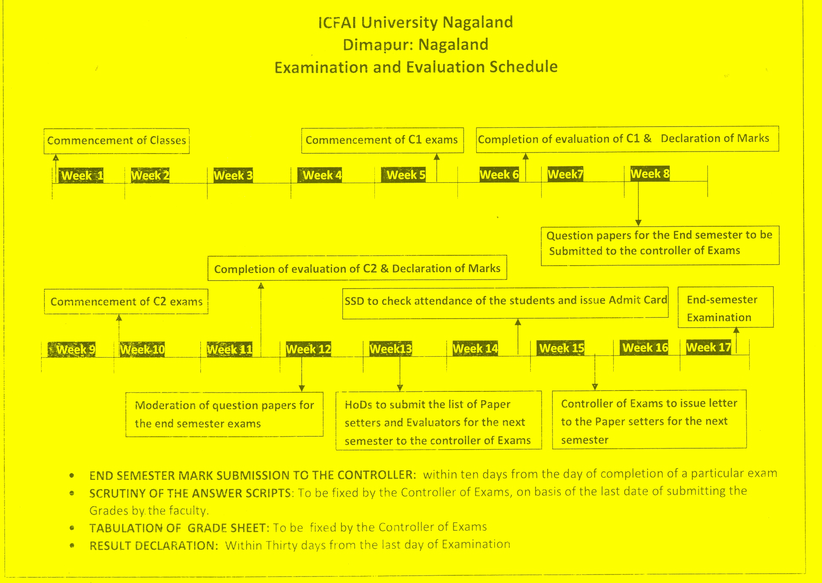**ANNEXURE – VI (B)**