ANNEXURE - VIII
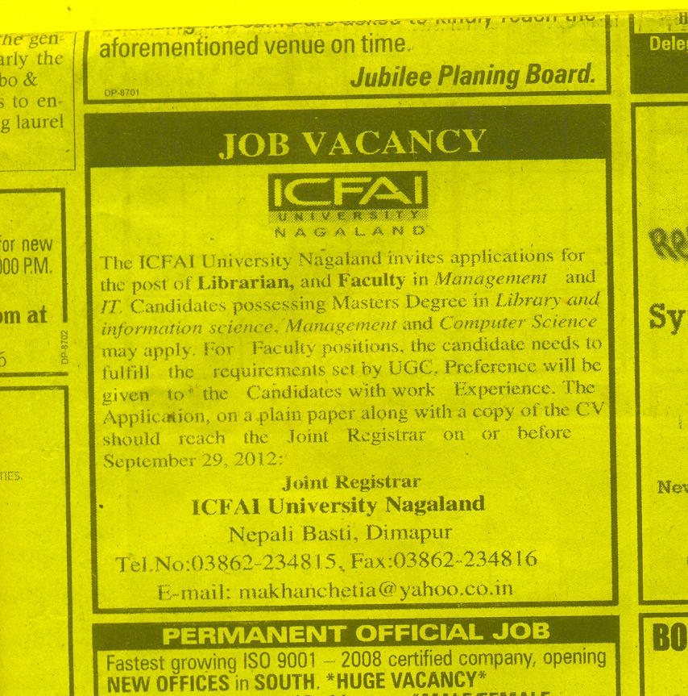
NEWSPAPER ADVERTISEMENT FOR FACULTY RECRUITMENT:

